**Bala Ayyappan A**

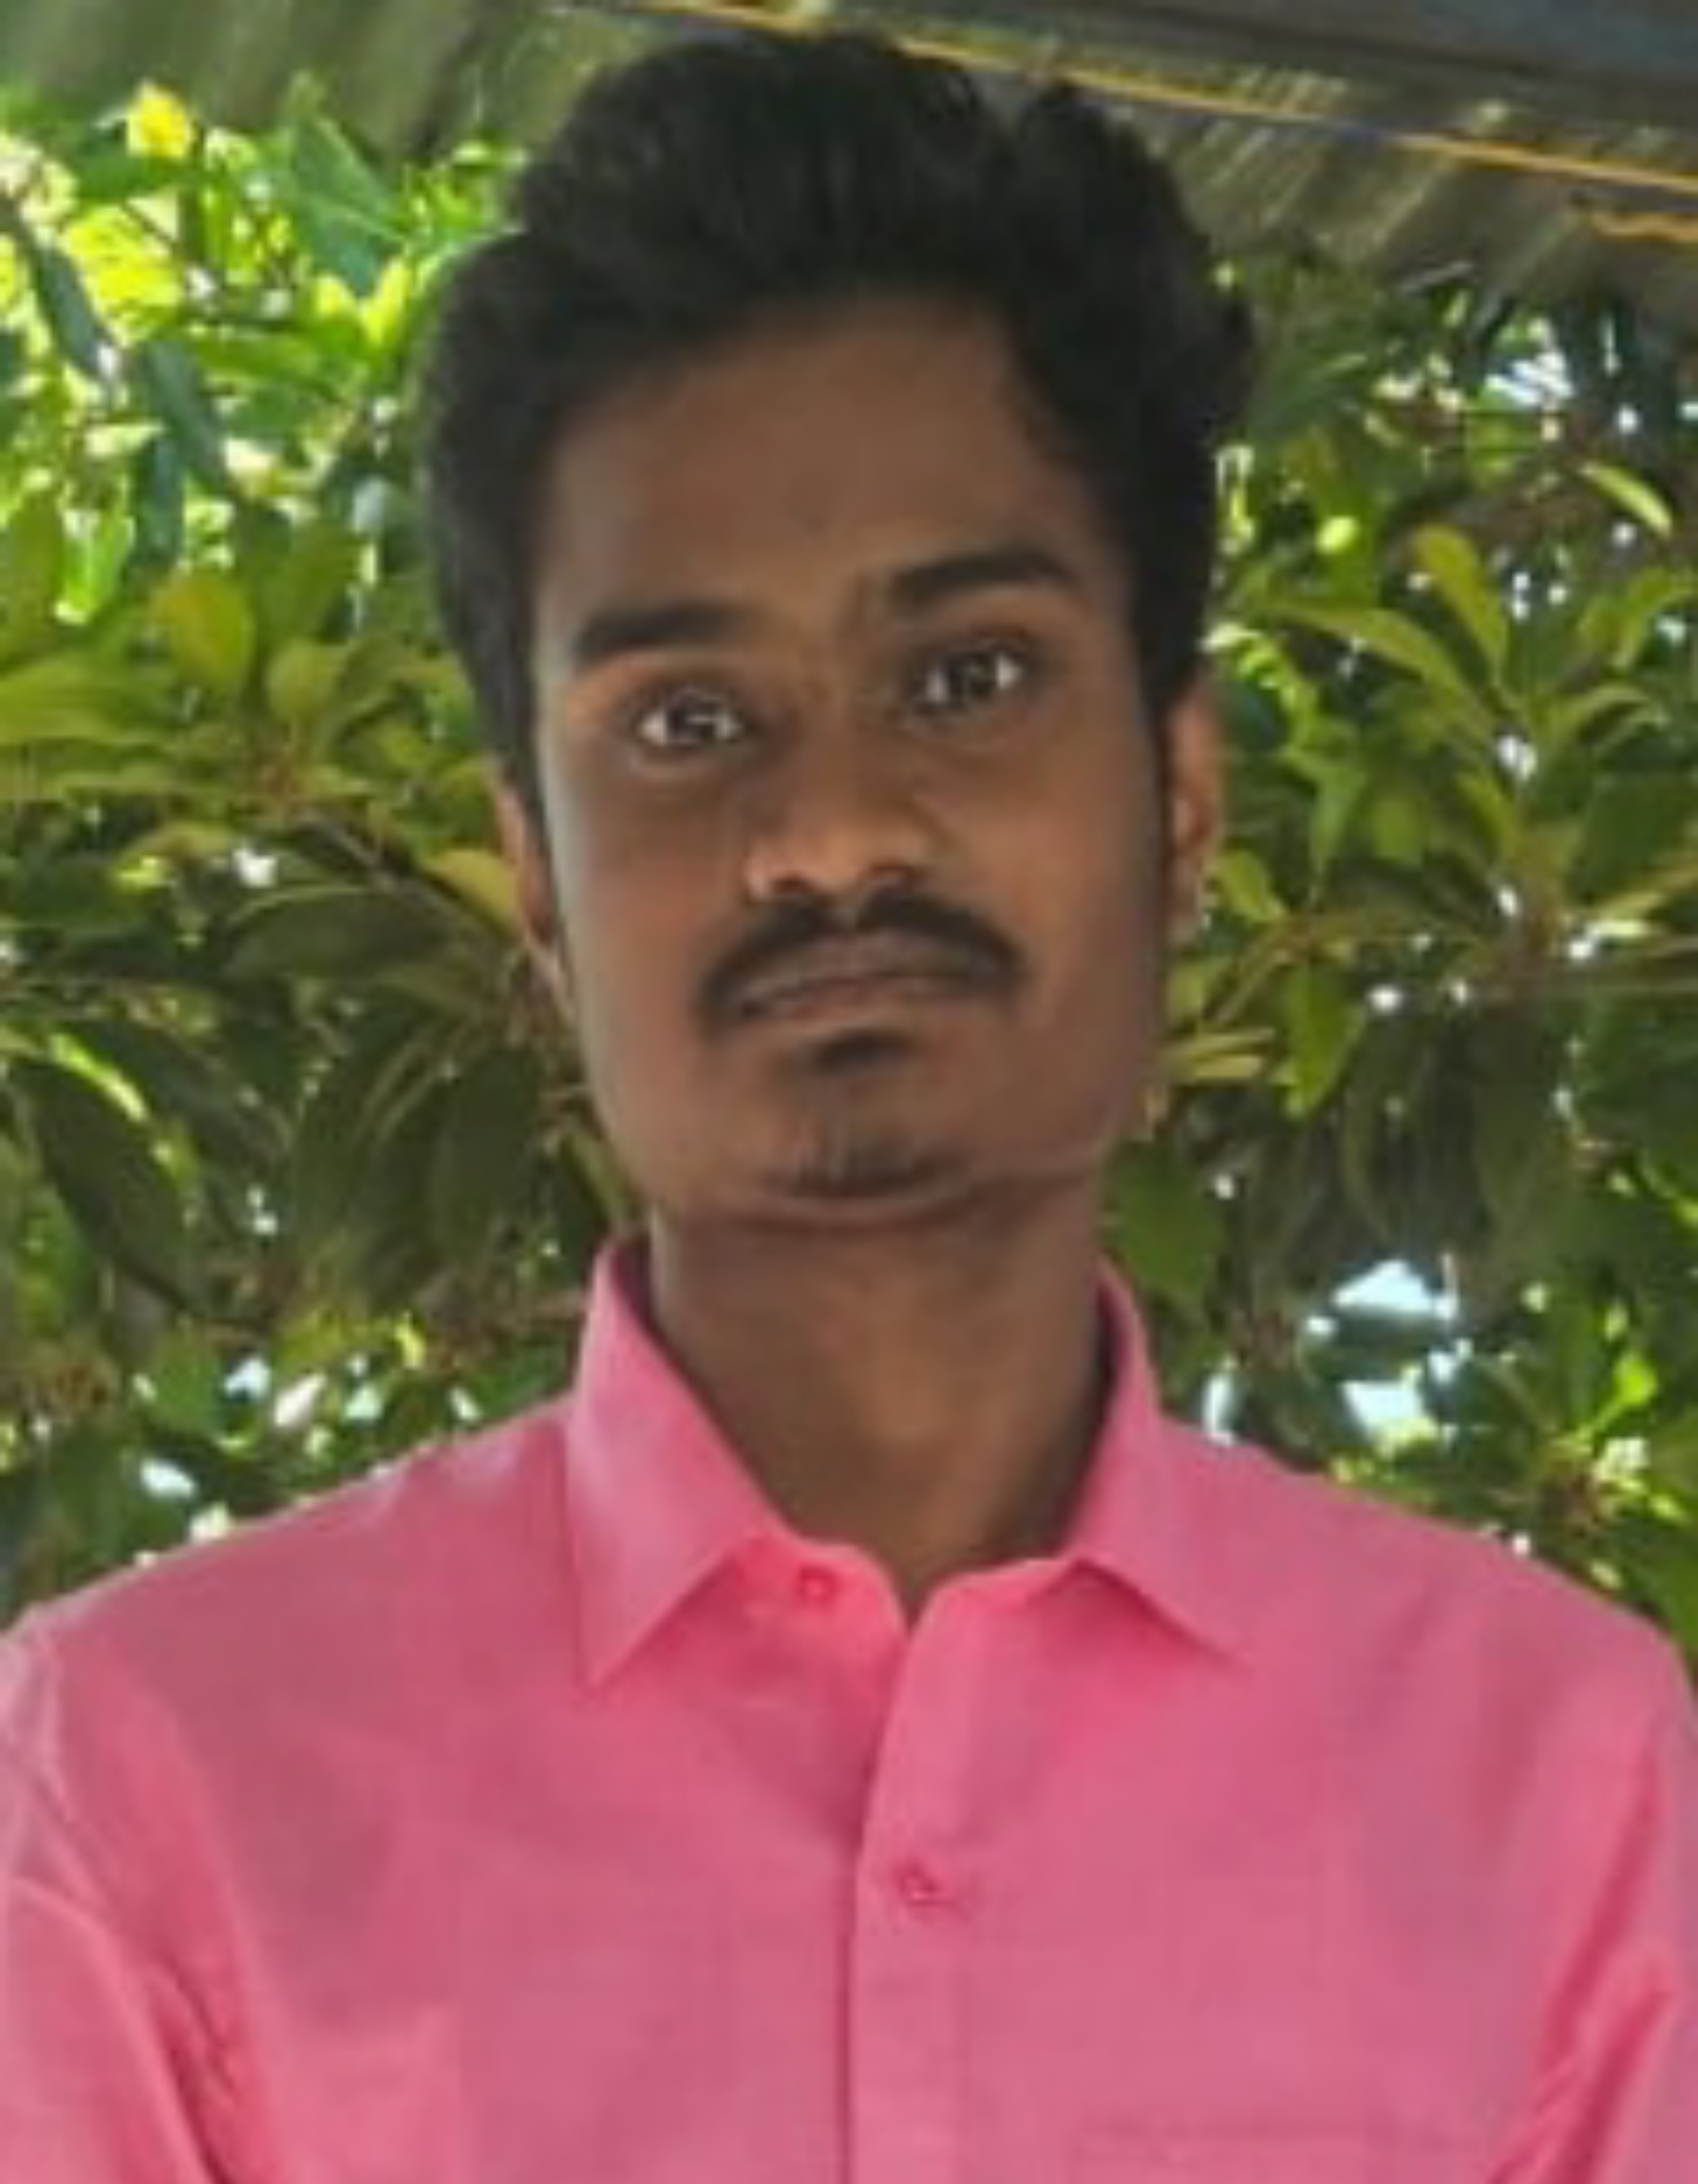

274/1, Thiroupathy Amman Kovil Street,

Vallathirakkottai, Alangudi TK,

Pudukkottai, Tamil Nadu- 622303.

Contact : +91 9751717751

Email : [bala060604@gmail.com](mailto:bala060604@gmail.com)

# OBJECTIVE

Looking for an internship in accounting to make the most out of the course and polish the skills learned by working with people who have incredible experience in this domain to hone my organizational skills and teamwork abilities.

# EDUCATION

|  |  |  |  |
| --- | --- | --- | --- |
| **COURSES** | **SCHOOL/COLLEGE** | **YEAR OF PASSING** | **Secured Score** |
| **B.Tech. Artificial Intelligence and Data Science** | Chettinad College Of Engineering and Technology, Karur. | Pursuing Degree | -NA- |
| **HSC** (Higher Secondary-Second Year) | Mount Zion Matric Hr Sec School, Pudukkottai. | 2022 | 65% |
| **SSLC** (Secondary School) | Mount Zion Matric Hr Sec School, Pudukkottai. | 2020 | 58% |

**COURSES**

|  |  |  |
| --- | --- | --- |
| **Title** | **Institute** | **Secured Score** |
| **Basics of Python** | Sololearn | -NA- |
| **Data Science** | Internshala | 73% |

# EXTRACURRICULAR ACTIVITIES

1. Participated in National level Symposium at **M. Kumarasamy College of Engineering**, Karur.
2. Attended International conference AMHEE in JSS, Mysore.
3. Attended national level symposium at **UCE**, **BIT Campus**, Tiruchirappalli.
4. Participated in **AWS Deep Racer 2.0 League**, 48 Hours Boot camp at **KGISL Institute of Technology**, Coimbatore.

# PROJECTS

1. **Visualized road accident data of Tamil Nadu.**

The data has been collected from Open Government and it has been visualized using python and its library.

# STRENGTH

* Flexibility and Adaptability to work in any environment.
* Willingness to accept any challenge irrespective of its complexity.
* Good team player.

# LANGUAGES

* Tamil (R, W& S)
* English (R, W & S)

# PERONAL DETAILS

**Name**  **:** Bala Ayyappan A

**Father’s Name** **:** Arunachalam M

**Date of Birth :** 06/06/2004

**Marital Status** **:** Single

**Gender**  **:** Male

**Nationality**  **:** Indian

**State**  **:** Tamil Nadu

# DECLARATION

I do hereby declare that the information contained herein is true and correct to the best of my knowledge and belief.

Place: Pudukkottai Yours Truly,

Date: 27/07/2023 **BALA AYYAPPAN A**